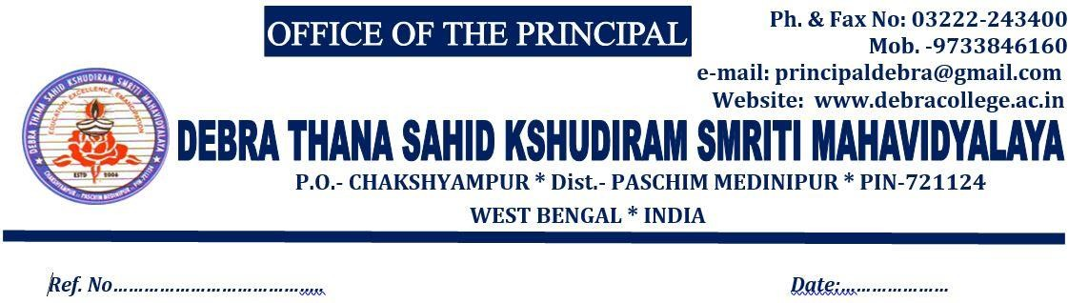
16/09/2024
4112/DTSKSM//24
/

Name of the suspended Employee | Name of the office/Institution with address | Suspended  from | Reason for Suspension | Any other Details
NIL | Debra Thana sahid Kshudiram Smriti Mahavidyalaya  Chakshyampur, Debra  Paschim Medinipur 721124 | NA | NA | NA

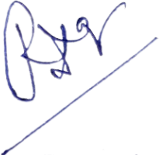

Dr. Rupa Dasgupta Principal
